CONFIDENTIALITY AGREEMENT TEMPLATE
I, Mr/Ms [NAME AND SURNAME], with identification document (NIE/Passport) no. [insert number], in my capacity as [insert contractual arrangement or temporary assignment] and in the performance of the duties entrusted to me at the University of Granada, insofar as these involve access to and use of confidential information belonging to the University, hereby undertake to comply with this Confidentiality Agreement:
Confidential information is understood as all information which is identified as such or which, by its very nature, clearly holds such status, regardless of the medium in which it is obtained and even if it has been communicated verbally.
In any event, any information containing personal data shall have this status, by virtue of article 4.1 of Regulation (EU) 2016/679 of the European Parliament and of the Council of 27 April 2016 on the protection of natural persons with regard to the processing of personal data and on the free movement of such data, and repealing Directive 95/46/EC (General Data Protection Regulation; hereinafter GDPR), whereby personal data is understood as "any information relating to an identified or identifiable natural person (‘data subject’); an identifiable natural person is one who can be identified, directly or indirectly, in particular by reference to an identifier such as a name, an identification number, location data, an online identifier or to one or more factors specific to the physical, physiological, genetic, mental, economic, cultural or social identity of that natural person".
I am hereby obliged to maintain due confidentiality with regard to any personal data that I may become aware of in the course of performing the aforementioned activity, remaining subject to the provisions of the GDPR and Spanish Organic Law 3/2018, of 5 December, on the Protection of Personal Data and Guarantee of Digital Rights.
At the end of my relationship with the UNIVERSITY OF GRANADA, I undertake to return all materials in my possession, paper-based or digital, which may contain confidential information.

This Confidentiality Agreement will remain in force indefinitely, even after my relationship with the UNIVERSITY OF GRANADA has ended, unless expressly agreed otherwise.

In witness whereof, I hereby sign this Agreement in
[town/city], on [date] of [month] of [year]
[signature]
[name and surname]

Basic information on personal data protection
Controller: | UNIVERSITY OF GRANADA
Legal basis: | The University of Granada is entitled to process your data as this is necessary to fulfil a legal obligation applicable to the data controller: Article 6.1.c) of the General Data Protection Regulation
Purpose: | To manage your Confidentiality Agreement
Recipients: | No data communications are envisaged
Rights: | You may request access, objection, rectification, erasure or restriction of the processing of your data, as specified in the "Additional Information" section. | 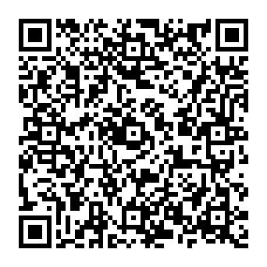
Additional information: | You can view additional and detailed information on data protection via the following link: University of Granada Secretary's Office > INFORMATIVE CLAUSES ON DATA PROTECTION | University of Granada (ugr.es)

