DECLARATION OF AUTHORSHIP AND ORIGINALITY
FOR DOCTORAL THESES
The doctoral student [NAME AND SURNAMES], with [ID document/passport/DNI] no.: [ID document no.] and the supervisor of the thesis [full name of thesis], of the Doctoral Programme [name of programme]

We hereby guarantee, by signing this doctoral thesis, that the work has been carried out by the doctoral student under the direction of their supervisor and, to the best of our knowledge, the rights of other authors have been respected by citing them when their results or publications have been used in the completion of the work.

Granada, [date]

THESIS SUPERVISOR | DOCTORAL STUDENT
[name and surnames] | [name and surnames]

Basic information on the protection of your personal data
Controller: | UNIVERSITY OF GRANADA
Legal basis: | The University of Granada is entitled to process your data as this is necessary for the fulfillment of a mission carried out in the public interest or in the exercise of public powers conferred on the person responsible for it: Article 6.1.e) of the General Data Protection Regulation
Purpose: | To manage your declaration of authorship and originality
Recipients: | No data communications are envisaged
Rights: | You may request access, objection, rectification, erasure or restriction of the processing of your data, as specified in the "Additional Information" section. | 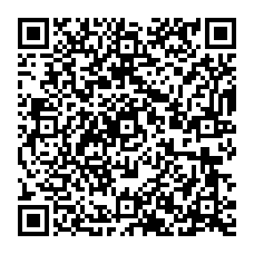
Additional information: | You can view additional and detailed information on data protection via the following link: https://secretariageneral.ugr.es/pages/proteccion_datos/leyendas-informativas/_img/informacionadicionalproduccioninvestigadora/%21

