DECLARATION OF AUTHORSHIP AND ORIGINALITY
FOR MASTER'S DISSERTATIONS
[NAME AND SURNAMES], with [ID document/passport/DNI] no.: [document no.], a student on the Master's Degree in [name of Master's Degree] at the Faculty of [name of Faculty or School], in relation to the Master's Dissertation [name of master's dissertation] submitted for defence and evaluation in the [20--/20--] academic year, hereby declares that they attest to the originality of this work, understood in the sense that they have not used sources without duly citing them.

Basic information on the protection of your personal data
Controller: | UNIVERSITY OF GRANADA
Legal basis: | The University of Granada is entitled to process your data as this is necessary to fulfil a legal obligation applicable to the data controller: Article 6.1.c) of the General Data Protection Regulation
Purpose: | To manage your declaration of authorship and originality
Recipients: | No data communications are envisaged
Rights: | You may request access, objection, rectification, erasure or restriction of the processing of your data, as specified in the "Additional Information" section. | 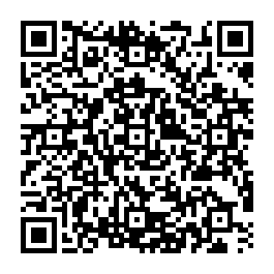
Additional information: | You can view additional and detailed information on data protection at the following link: https://secretariageneral.ugr.es/pages/proteccion_datos/leyendas-informativas/_img/informacionadicionalgestionacademica/%21

