DECLARATION OF RESPONSIBILITY FOR ERASMUS STUDY GRANTS

Antonio López Romero, with ID document/Passport no.: 22222222N and email for notification purposes: example@correo.ugr.es

I HEREBY DECLARE THAT:

I have not previously been a recipient of an Erasmus study grant IN THE SAME STUDY CYCLE as a student at the UGR or another institution.
I have previously been a recipient of an Erasmus study grant IN THE SAME STUDY CYCLE as a student at the UGR or another institution.

If yes, please provide details:

Educational level: | Undergraduate | - Master's | - Doctorate
Home university: | Granada
Host university: | Southern Denmark
Academic year: | 2020/2021
Number of months of mobility period: | 7

Granada, 18 January 2021

[signature]

Antonio López Romero

Basic information on the protection of your personal data
Controller: | UNIVERSITY OF GRANADA
Legal basis: | The University of Granada is legitimized for the processing of your data, being applicable the legal bases provided for in art. 6.1 of the General Data Protection Regulation
Purpose: | To manage your declaration of responsibility
Recipients: | No data communications are envisaged
Rights: | You may request access, objection, rectification, erasure or restriction of the processing of your data, as specified in the "Additional Information" section. | 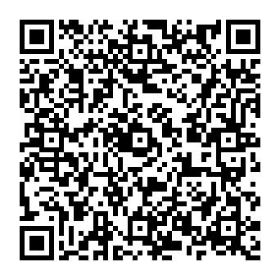
Additional information: | You can view additional and detailed information on data protection via the following link: University of Granada Secretary's Office > INFORMATIVE CLAUSES ON DATA PROTECTION | University of Granada (ugr.es)

